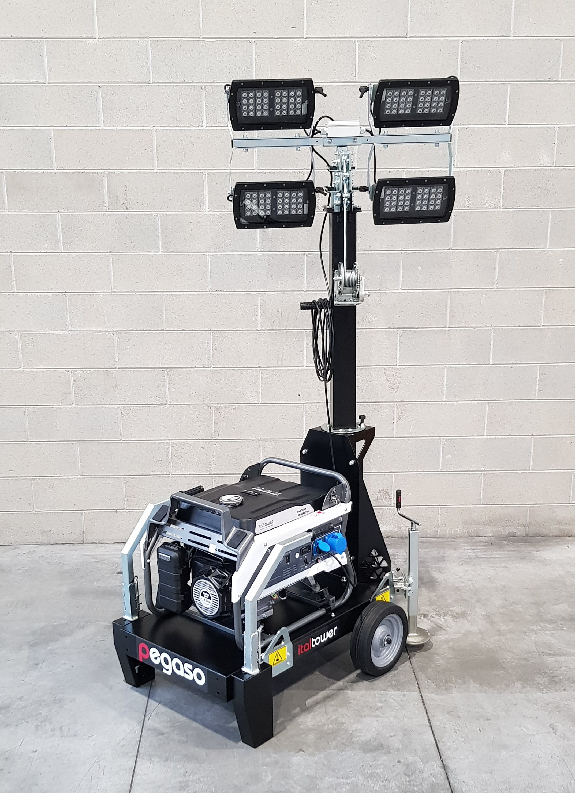

Floodlight | Lumen | Light coverage
4x160 MultiLED | 81400 | 2400 mq
4x75W MultiLED | 36900 | 1500 mq

Performance data
Rated frequency | 50Hz
Rated voltage | 230 VAC
Rated Power | 5.4 kW
Operating temp | -30/+50°C
Sound level @7m | 70 dB
Engine
Model | Italtower 14 HP
Speed | 3000 rpm
Coolant | Air
Cylinders | 1
Emissions | Stage V
Alternator
Type | Self-excited
Rated output | 6 kVA
Regulation | With brushes
Voltage accurancy | AVR
Consumption
Tank | 25 l
Fuel | Gasoline
Autonomy | 218 h
Fuel consumption | 1.8 l/h @ 75%
Electric manual panel | 1x230V schuko + 1x230V ECC 32A 3P socket and 12VDC socket
Galvanized Mast
Lifting system | Manual with winch
Rotation | 350 °
Max height | 5,5 m
Max speed wind | 80 Km/h
Canopy and trailer
Trailer | Hand trolley
Basement | Steel base frame, epoxy powder painted
Stabilizers | 2
Canopy | Powder coating paint
Optional included as standard | Thermal switch and multmeter (V, Hz). Hour counter
Shipment
Dimension | 84x119x211 cm
Weight | 249 Kg

